Samenvatting – Data Exploration

**Steps of Data Exploration and Preparation**

* Terminology
* Normal Distribution
* Garabage in garbage out
* Why Data Exploration
* Step in Data Exploration

**Terminology**

* **Samples**
  + The set of instances/examples/observations/records/row

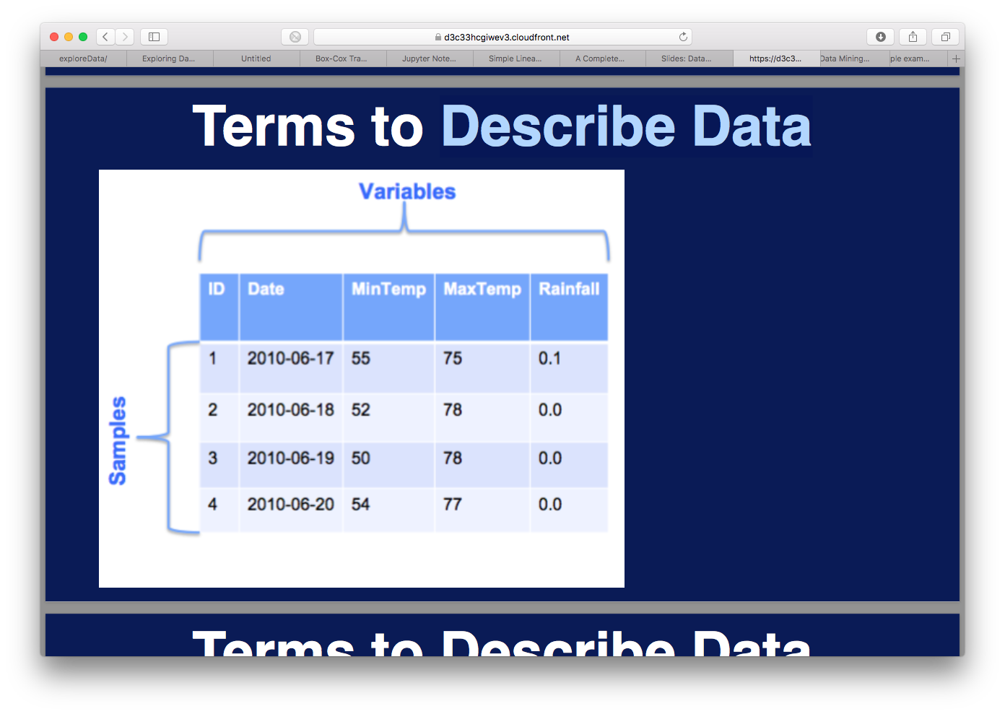

* **Variable**
  + Characteristic/Feature/Attribute/Column/Dimension of samples



**Variable Identification**

* **Variable:**
  + Numeric/Quantitative:
    - Can be used to compute or sort.
    - Integer: -1, 0, 1, 2
    - Float: -1.9, 0.05, 3.14
  + Categorical/Qualitative/Nominal
    - Label: Red, Blue, Green
    - Boolean: True, False

**Terminology**

* **Datatype:**
  + Domain of a variable (data, integer, float, text, boolean)



* **Model:**
  + Simplification of the real world that helps us understand/predict/tasks

**Normal distribution**

* Many variables are distributed normally



* Height dfference between men and women



Are men taller than women?



* Because they are normally distributed, we can use proven statistics (student T-test) to answer that!
* However, when data is not normally distributed the result may be invalid.

Not all data is normally distributed; we need to check so we know which instrument to use

Statistics do not flag when something is wrong; you make the difference between valid and invalid results.

**Garbage in 🡪 Garbage Out**

* Inconsistencies in data:
  + Incorrect data formats
  + Lower/Uppercase
  + Whitespaces in codes
  + Decimals converted to whole numbers
* Faults in reading data:
  + Wrong column headers
  + Comments interpreted as data
  + Weakly structured data (HTML)

**Why Data Exploration?**

* To understand the characteristics of the data
* To prepare the data for analysis
* Precedes analytical treatment of data
  + Remove problems before analysis
  + Investigate potential directions:
    - Would a very simple model work?

**Data Exploration**



**Steps of Data Exploration**

1. Check Data edges
2. Variable Identification
3. Univariate Analysis
4. Bi-variate Analysis
5. Missing Values
6. Outliers
7. Variable transformation
8. Variable creation

Steps 2 to 8 are called Feature Engineering.

1. **Check Data edges**
   1. Check number of rows
   2. Check number of columns
   3. Check first few rows
   4. Check last few rows
   5. Is the formatting ok?
   6. Are the values within realm of reality?

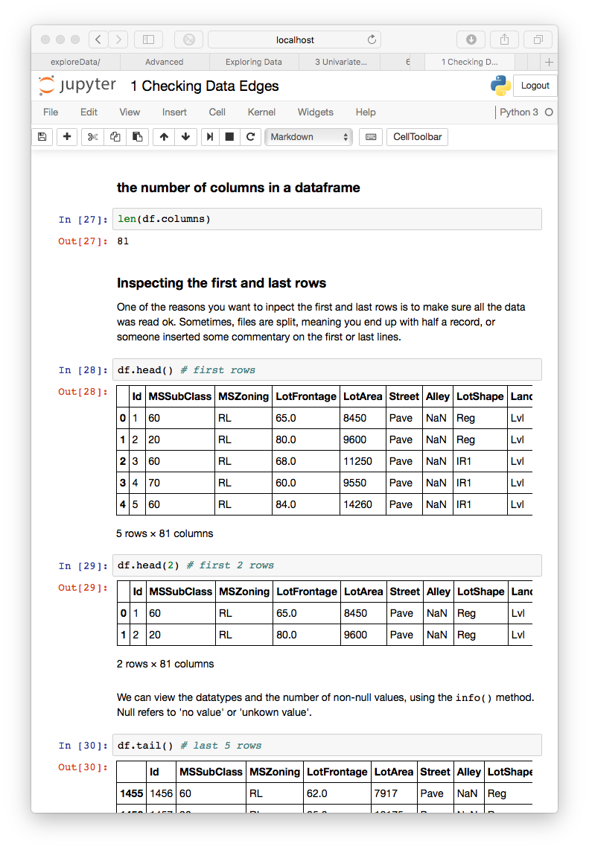

1. **Codebook**
   1. A codebook describes the contents, structure and layout of a data collection

**Per set:**

* + Where did the data come from?
  + How did they collect the data (sampling, response rate)
  + Technical info about files (how many, size, format)

**Per variable:**

* + Position
  + Name
  + Label (clearly describing meaning)
  + Values (classes, range or an example)
  + Datatype
  + Numerical/Categorical
  + Predictor/Target Variable
  + Summary statistics

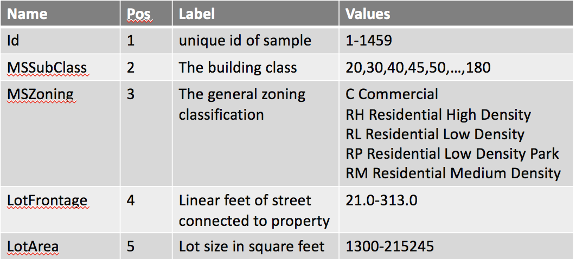

1. **Univariate Analysis**

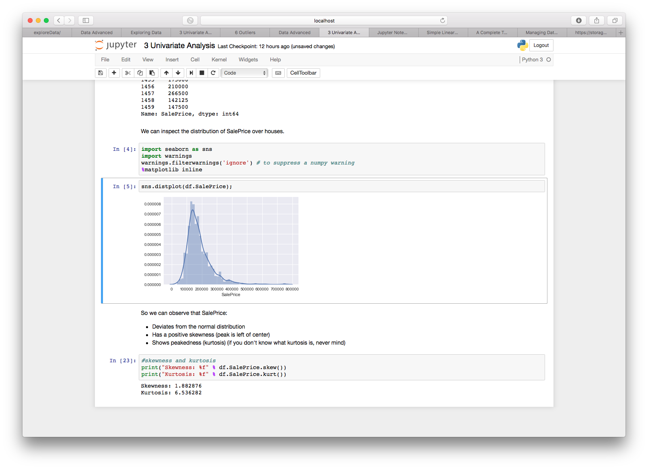

* 1. Not normal: left-skew, peaked

1. **Bi-variate Analysis**

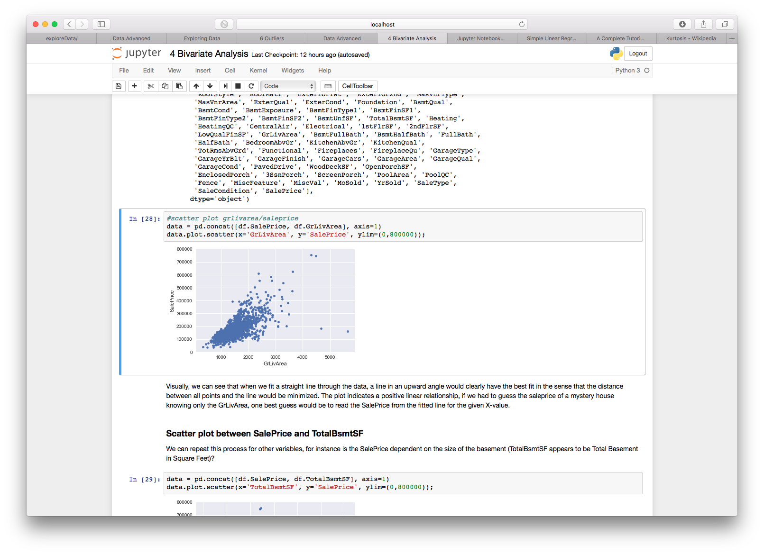

* 1. Related, but not clear of linear
  2. Outliers

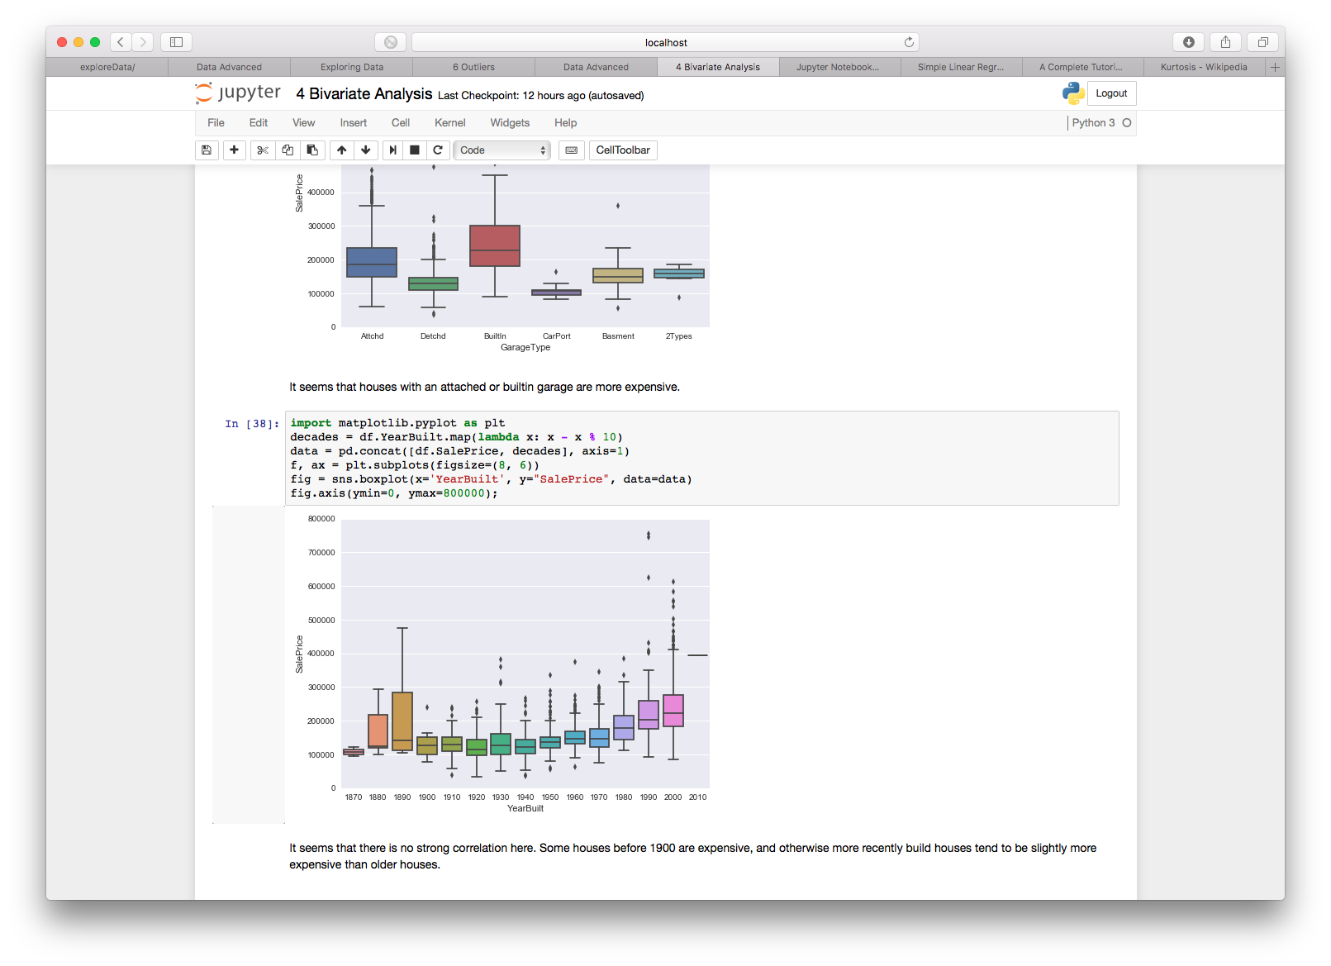Categorical:

* Buckets
* Box n Whisker
* Weak Relation

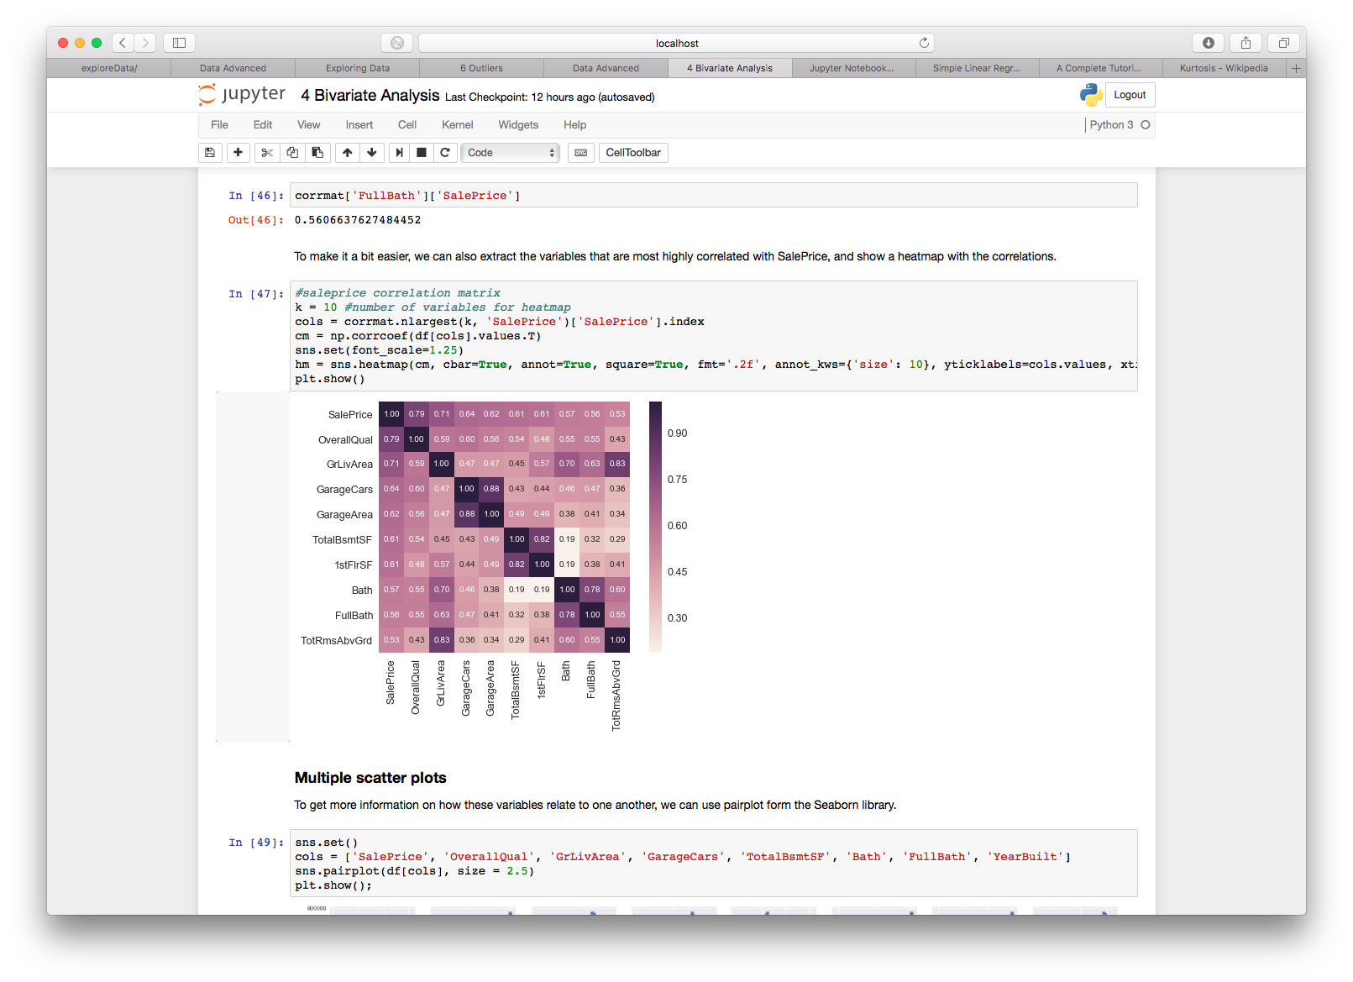

1. **Missing Data**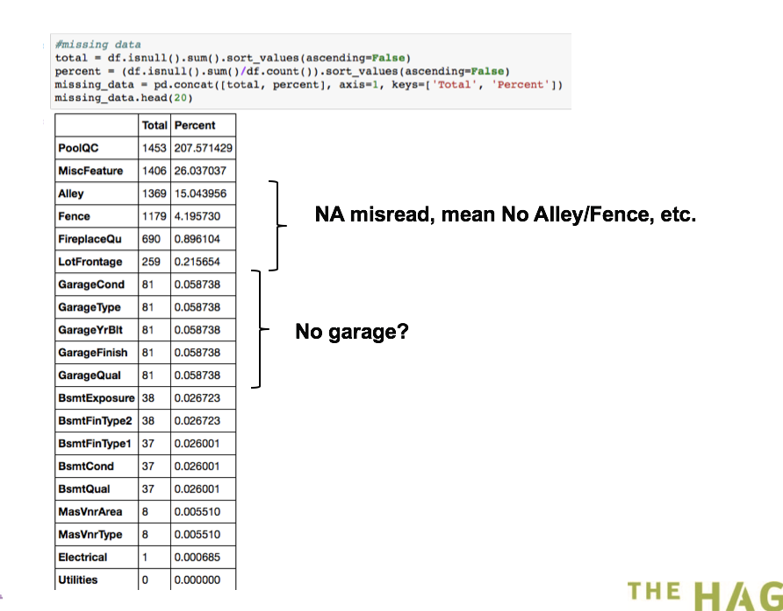
2. **Outliers**

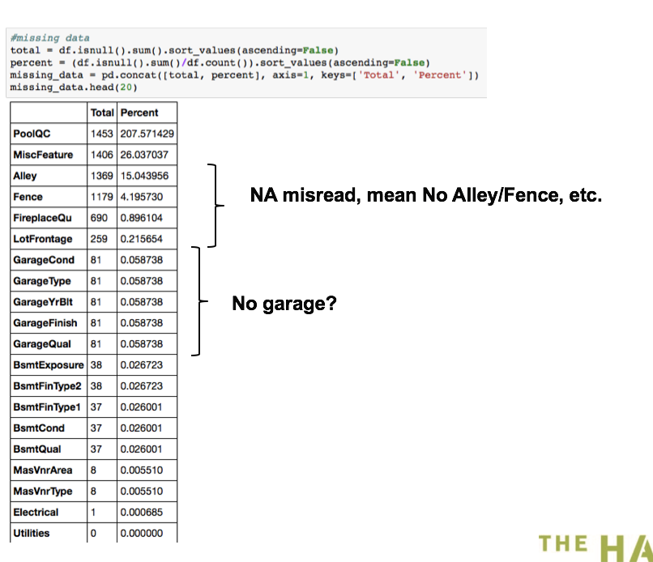

1. **Transformation**
   1. Normality and homoscedascity

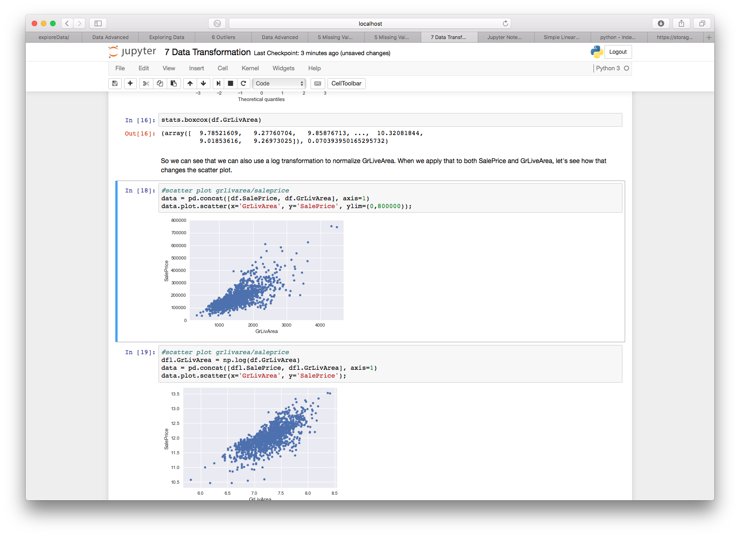

Analyze SalePrice

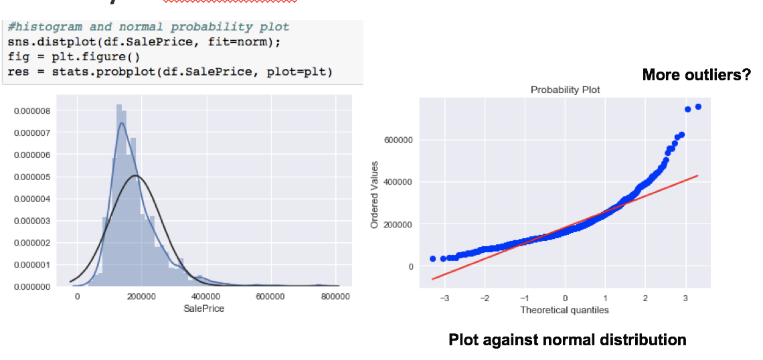

|  |  |
| --- | --- |
| **Box-Cox** | **transformation of Y** |
| -3 | −Y−3 |
| -2 | −Y−2 |
| -1 | −Y−1 = −1/Y |
| -0.5 | −Y−0.5 = −1/√Y |
| 0 | log(Y) |
| 0.5 | Y0.5 = √Y |
| 1 | Y |
| 2 | Y2 |
| 3 | Y3 |

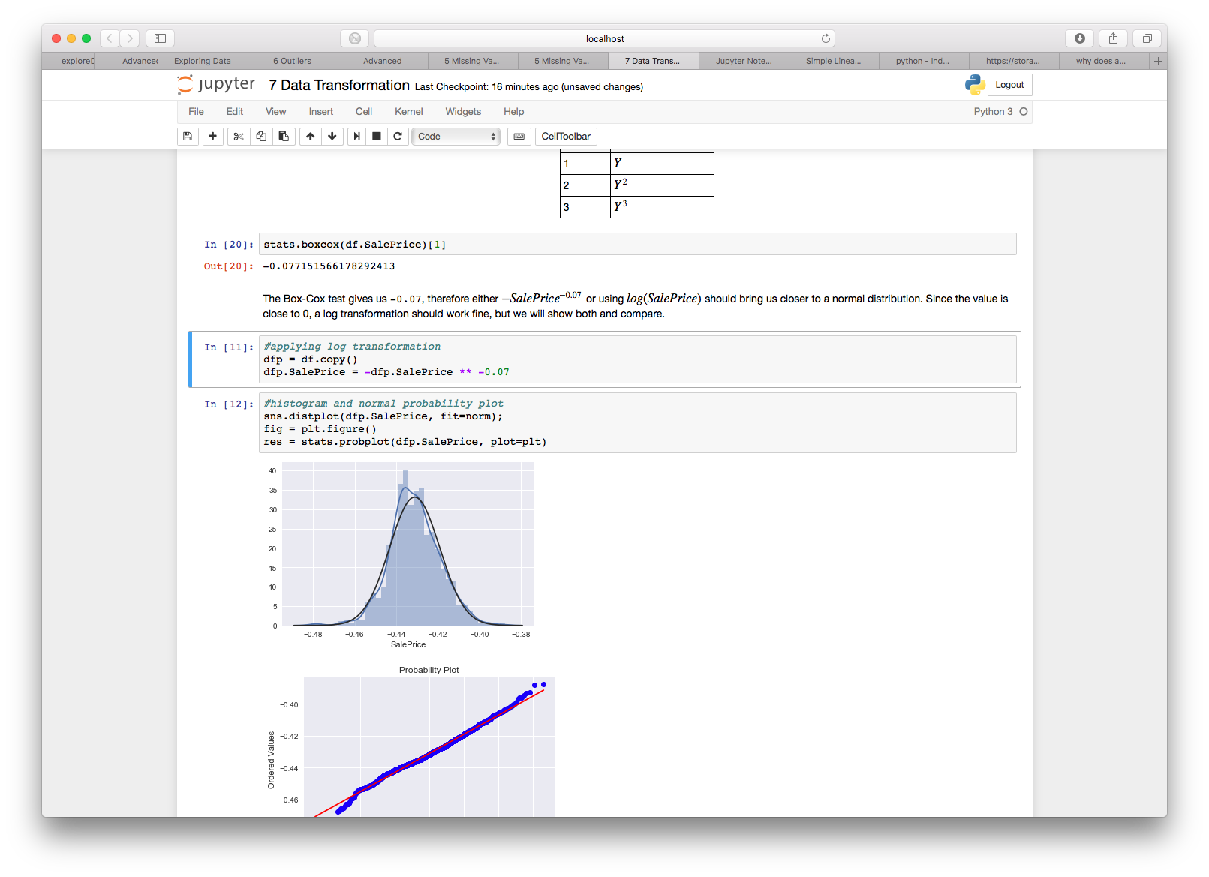

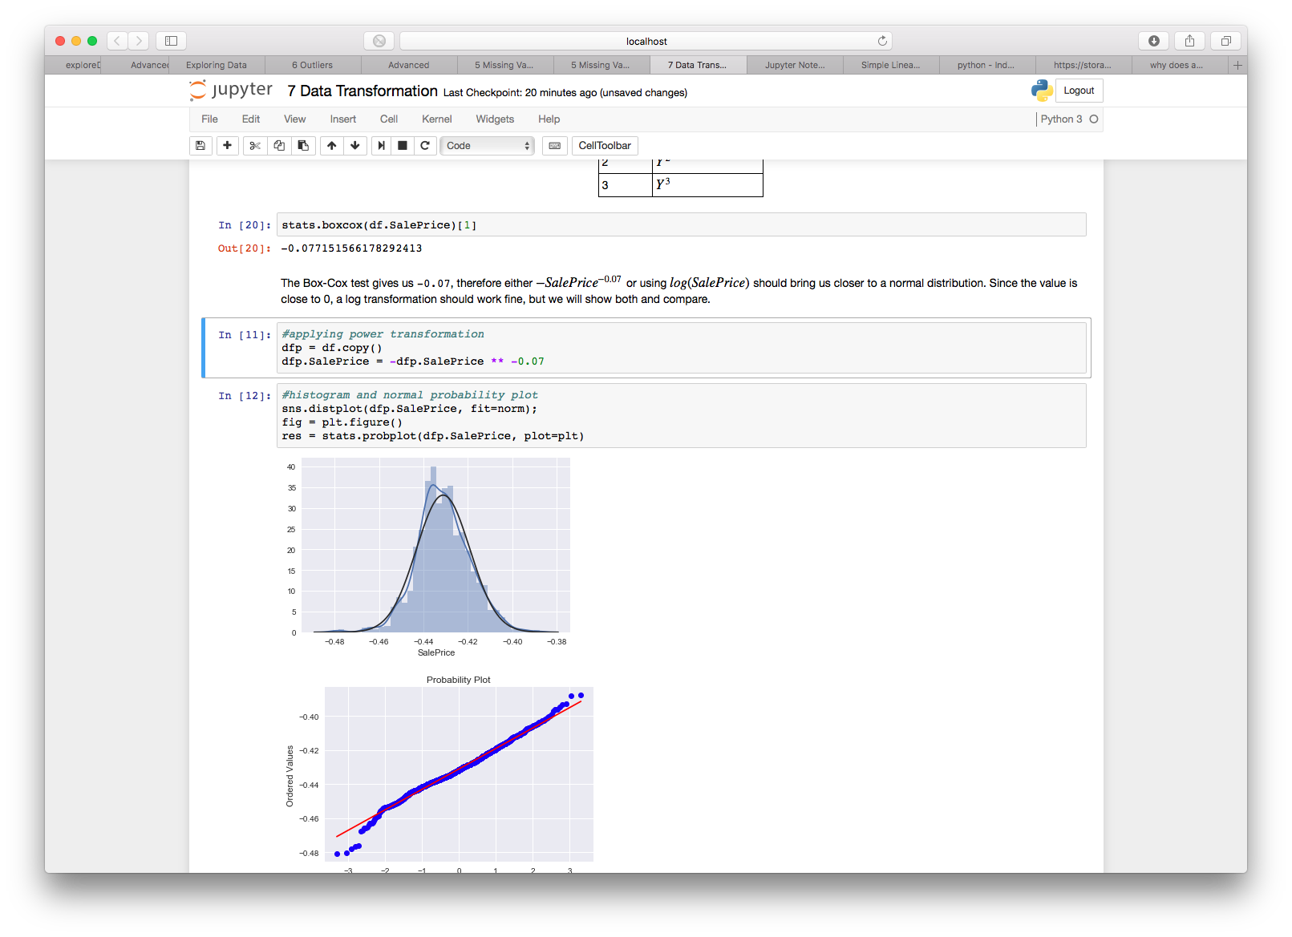

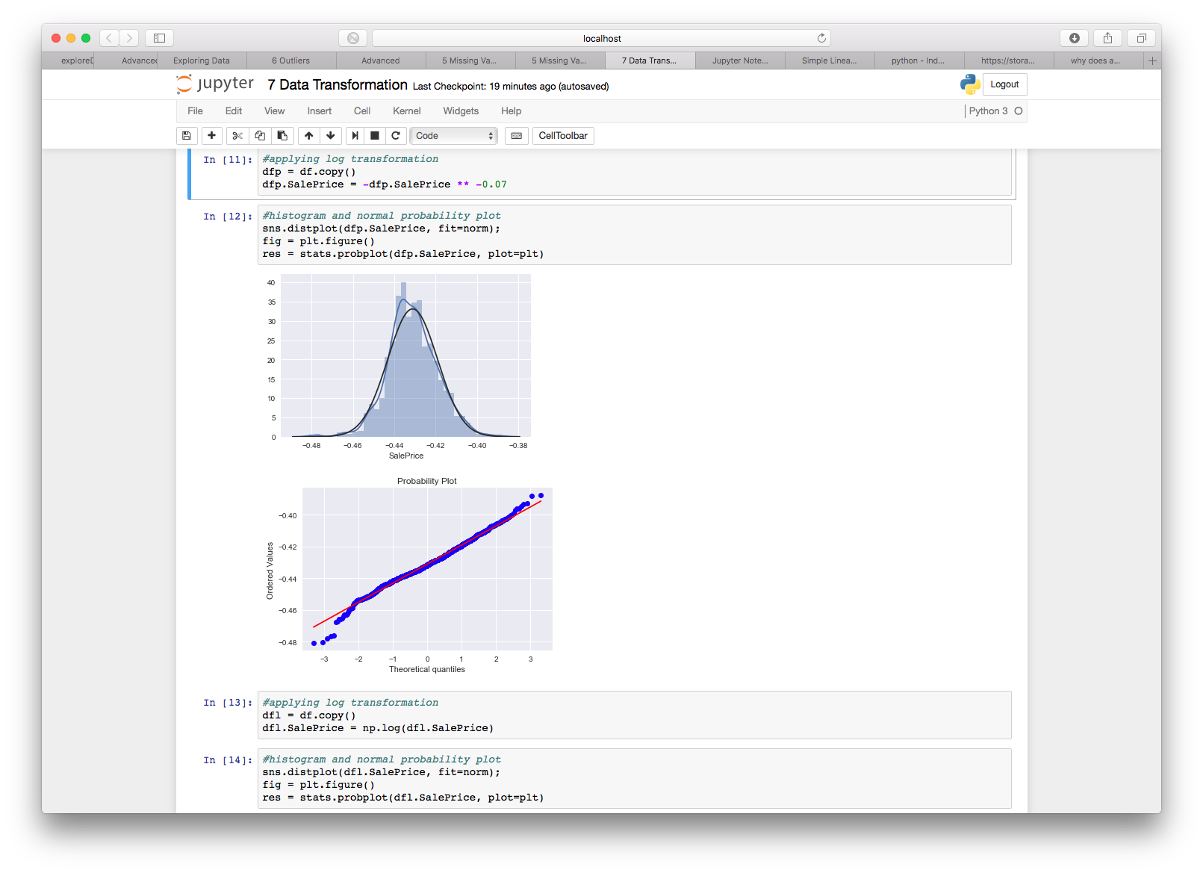

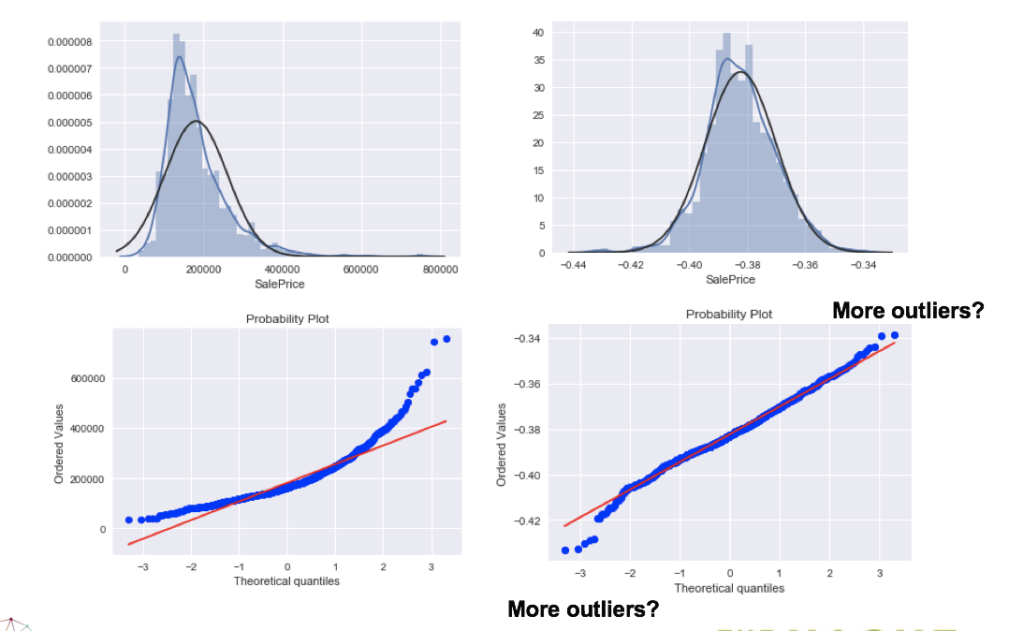

1. **Variable Creation**

* How can we use categorical values?

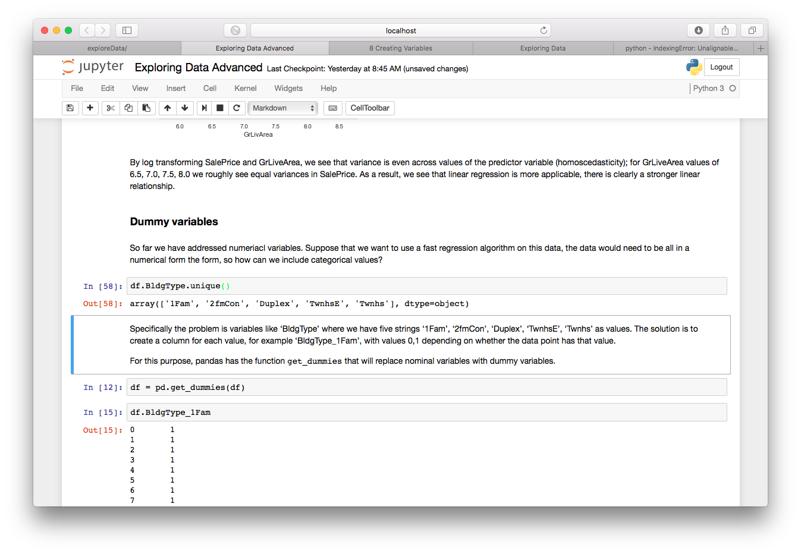

* Create separate variables for all values:
  + BldgType_1Fam = {0, 1}
  + BldgType_2fmCon = {0, 1}
  + BldgType_Duplex = {0, 1}

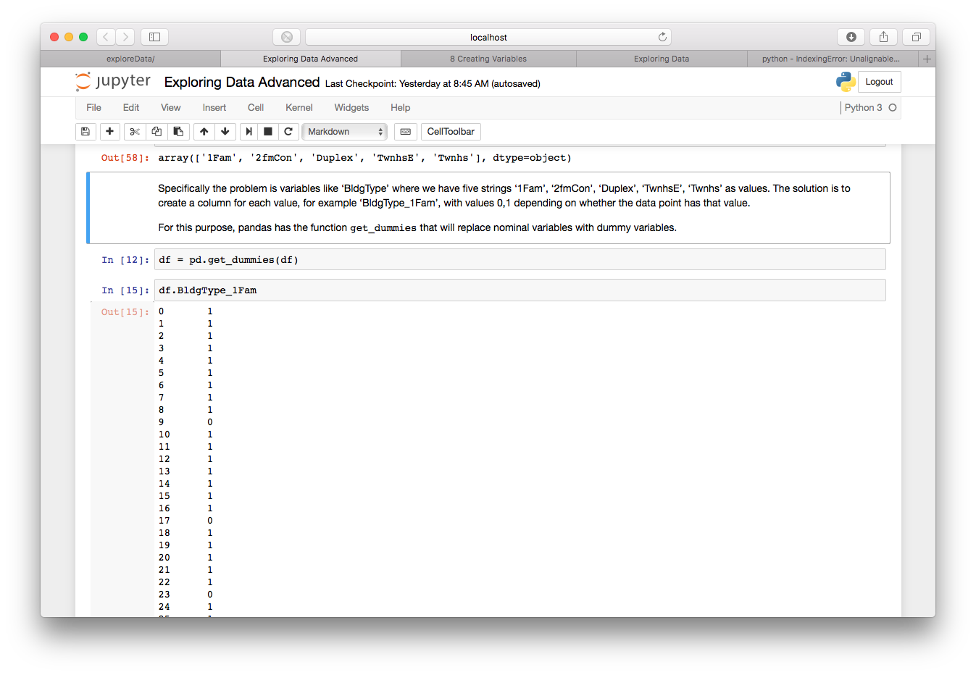

1. **Evaluation**

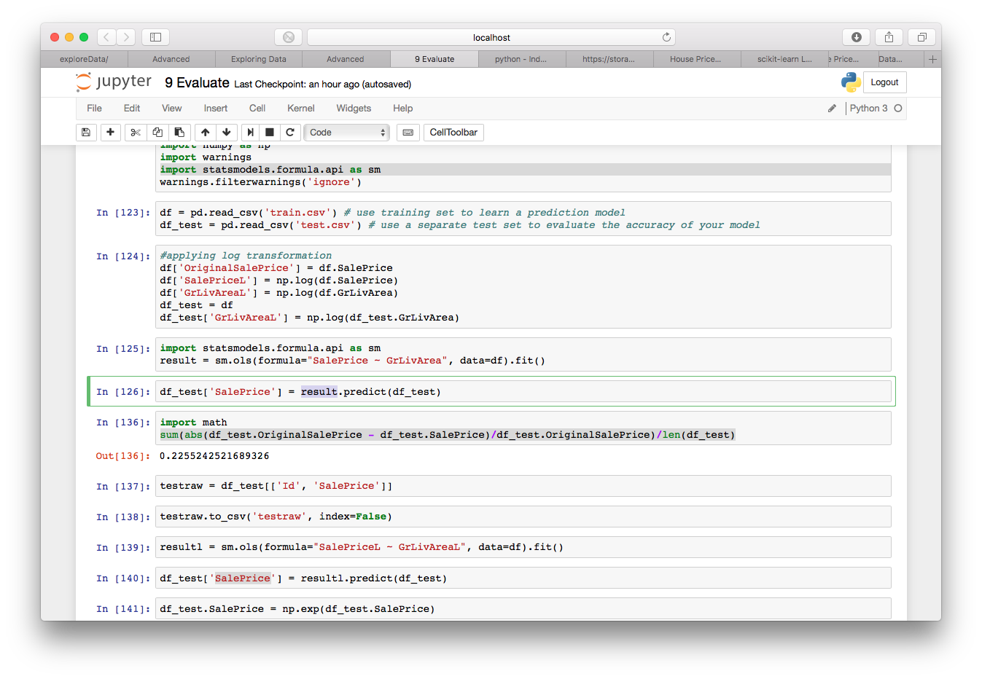

* Average % from actual SalePrice on trainset
  + Original: 22.55%
  + Transformed: 21.83%
* But there is a better way to evaluate

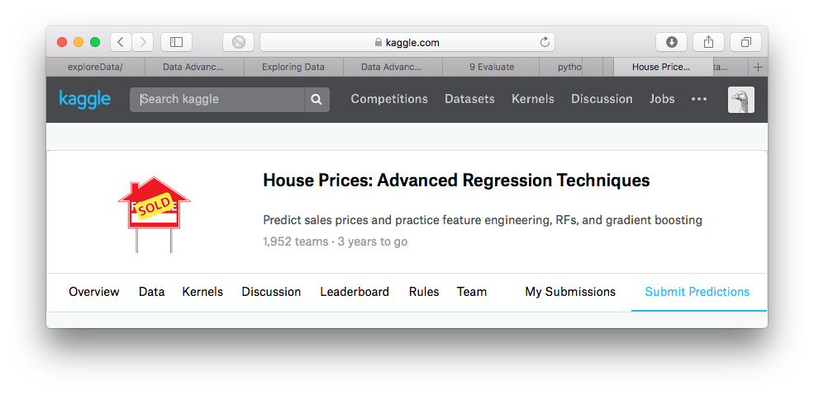

* Learn model training data
* Evaluate test data (no cheating)

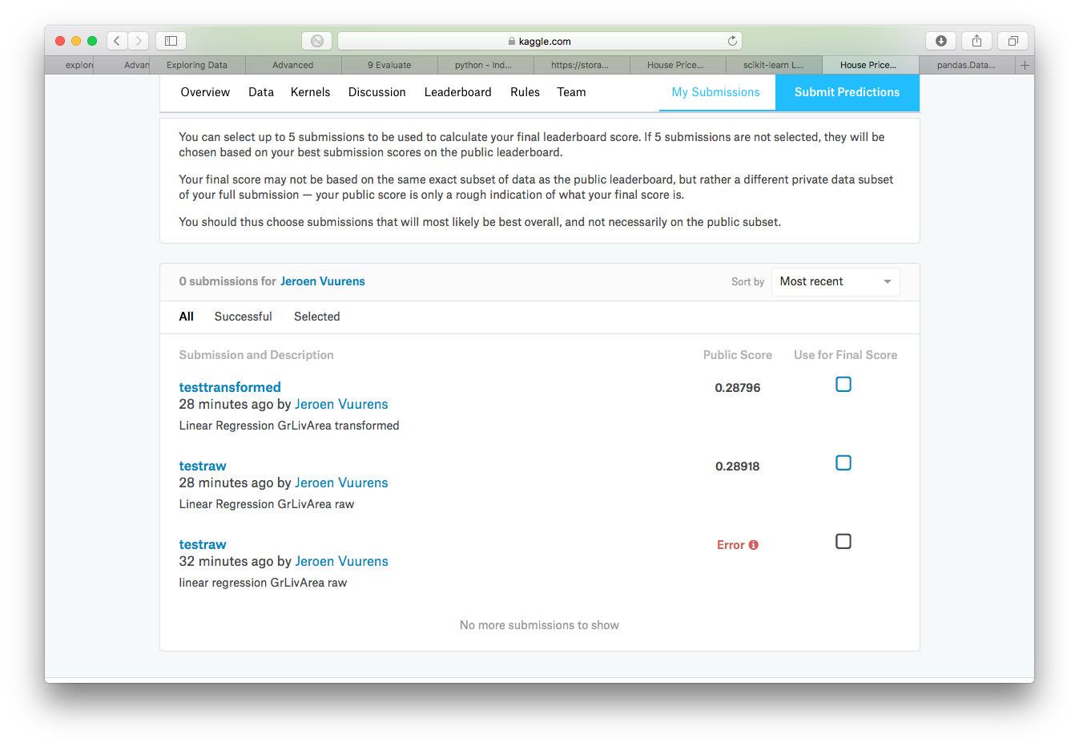

* Mean Root Squared Error (lower is better)
* Evaluate over separate test set is objective